AI Usage Declaration Form

Referencing the Output of Artificial Intelligence Language Models
Output text of an artificial intelligence language model (such as a ChatBot) for written assessment items of this unit will not be treated as your own work.
- If any output text is used, it must be quoted in italics, and the app or website must be referenced appropriately (AI language model Name/Chatbot Name, Developer or Organisation, date accessed).
• If any output ideas are used and paraphrased, the app or website must be referenced appropriately (AI language model Name/Chatbot Name, Developer or Organisation, date accessed).
- If the output of an artificial intelligence language model is prescribed by your Lecturer as an integral part of an assessment item, the app or website must be referenced appropriately (AI language model Name/Chatbot Name, Developer or Organisation, date accessed).
(excerpt from Unit Information)

Step 1: Select the declaration statement that best describes the level of AI tool usage in this assignment.
Table 1. Declaration Statement
Tick (ü) only 1 statement that applies | Declaration statements
Declaration 1:
We do not use any content generated by AI tools to be presented as our work.
Declaration 2:
We acknowledge the use of AI tool(s) to generate materials that aid with the process of completing this assessment (e.g. for background research or self-study). None of these materials are presented as our work.
Declaration 3:
We acknowledge the use of AI tool(s) to generate materials that are included in our work in modified forms.

Step 2: Complete the following form if you select either Declaration 2 or Declaration 3. You do not need to complete this section if you select Declaration 1.
Table 2. Details of AI Usage
Reference to one or more AI tools. Example: https://shorturl.at/8UT25 | Response:
List all prompts you have used. | Response:
Reflect on how you have used these AI tools, how they have helped with your assignment and the limitations you encountered. | Response:
Do you maintain an accessible AI prompt history that is verifiable by your lecturer if requested? | Yes / No  If no, provide explanations:

Step 3: Answer the following question only if you selected Declaration 3. You do not need to complete this section if you select Declaration 1 or Declaration 2.
How have you modified the generative AI’s output? You may include as many details as possible, including screenshots.

Student Signatures
Student ID | Full Name | Signature
S398425 | Nasla Maharjan | 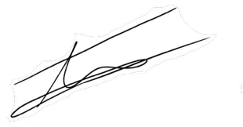
S395754 | Krish Rajbhandari | 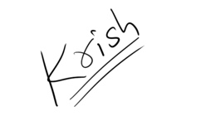
S393829 | Suyog Kadariya | 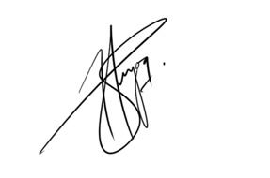

Date: 21st April, 2026

The contents of this AI Usage Declaration form have been adapted from:
- University of Birmingham (2025), Acknowledging and Citing the Use of Generative AI by Student, accessed on 4 Mar 2025. Link: https://www.birmingham.ac.uk/libraries/education-excellence/gai/acknowledging-gai-by-students
- University of Cambridge (2025), Template Declaration of the Use of Generative Artificial Intelligence, accessed on 4 Mar 2025. Link: https://www.cshss.cam.ac.uk/education/generative-artificial-intelligence-ai-and-scholarship/template-declaration-use-generative

